1-LinkedIn article about Navigation Propert

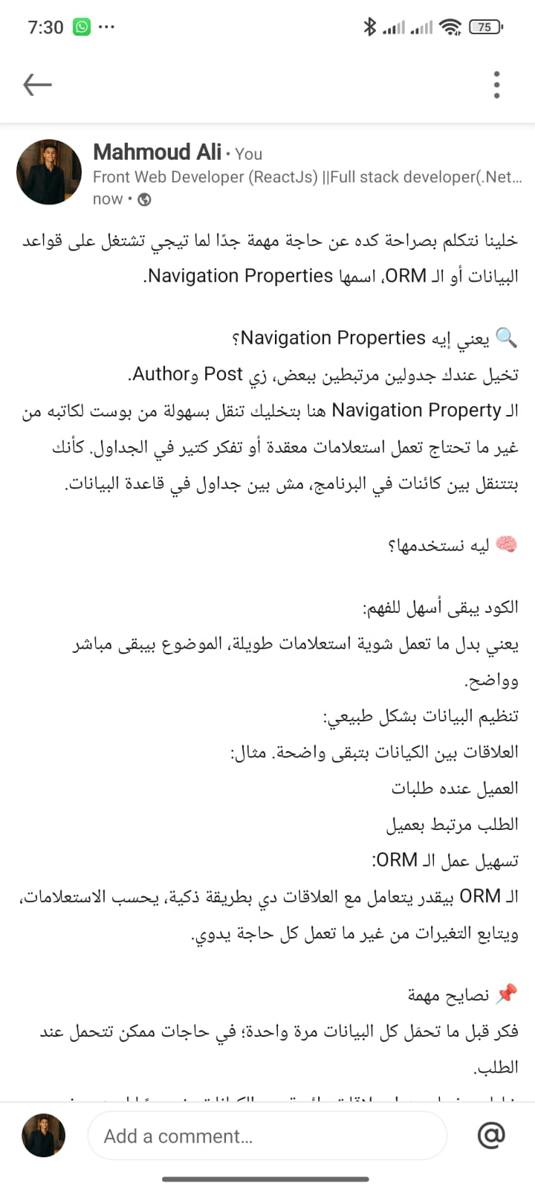
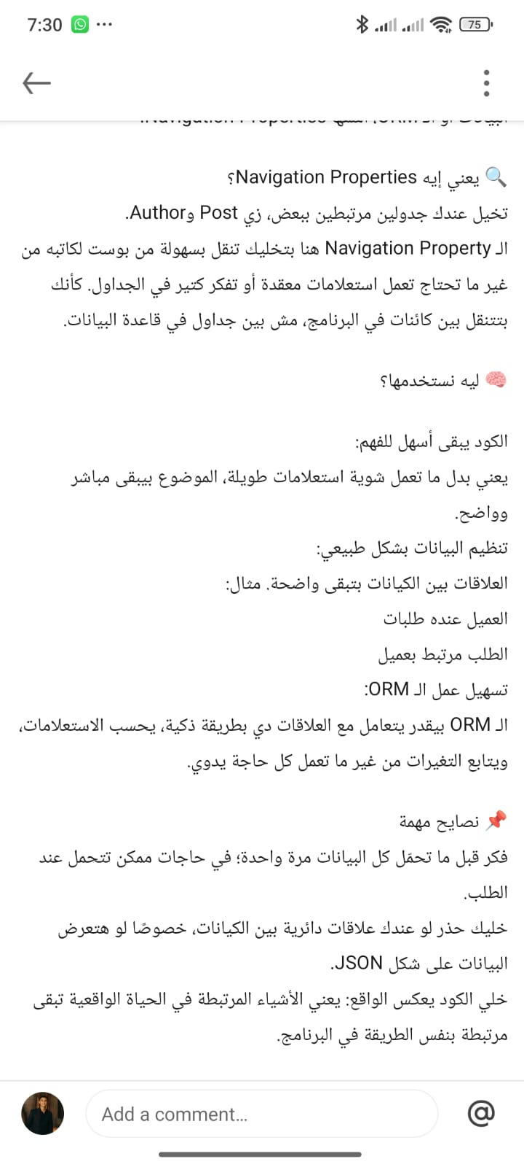

2- part02

- DB diagram screenshot project {1} E-commerce System

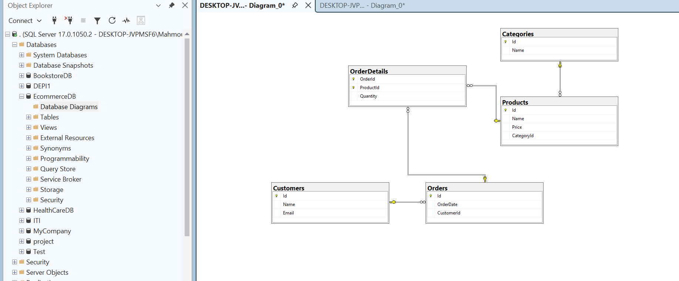

- DB diagram screenshot project {2} Health Care System

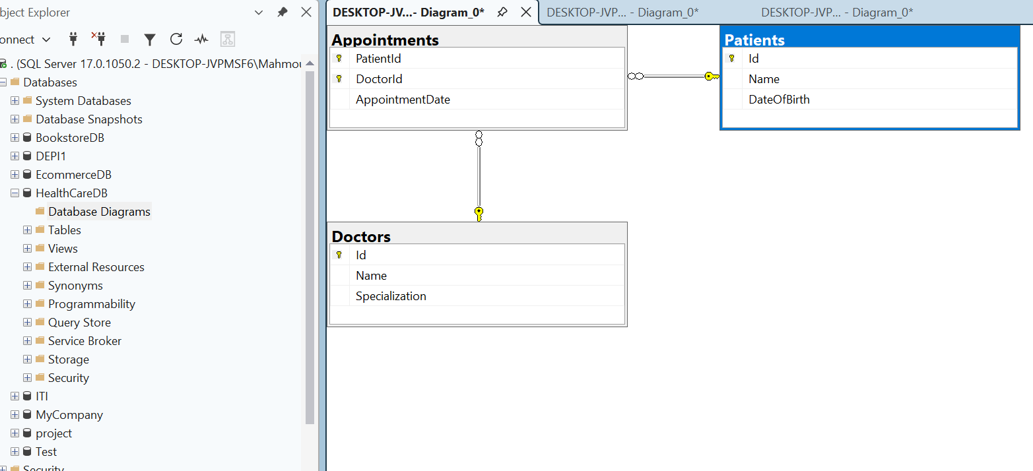

- DB diagram screenshot project {3} Library System

